

Visvesvaraya Technological University
BELAGAVI , KARNATAKA

Mini Project report on

“Heart Attack Prediction Using Machine Learning”

Submitted by

- Anvith BK 4JN22IS015
- Ayush KN 4JN22IS016
- Kiran Kumar R 4JN22IS057
- Lohith Gopi S 4JN22IS063

Under the guidance of Sharath Kumar SR, B.E, M.Tech
Assistant Professor, Dept. of IS&E, JNNCE, Shivamogga.

Department of Information Science & Engineering
JNN College of Engineering
Shivamogga-577204
2025-26







National Education Society®
JAWAHARLAL NEHRU NEW COLLEGE OF ENGINEERING
SHIVAMOGGA-577204

DEPARTMENT OF INFORMATION SCIENCE & ENGINEERING
CERTIFICATE
This is to certify that Mini Project entitled

“Vehicle Detection and AI Traffic Analysis”

Submitted by
  - Anvith BK 4JN22IS015
  - Ayush KN 4JN22IS016
  - Kiran Kumar R 4JN22IS057
  - Lohith Gopi S 4JN22IS063

Students of 5th semester B.E, ISE, in partial fulfillment of the requirement for the award of degree of Bachelor of Engineering in Information Science and Engineering under Visvesvaraya Technological University, Belagavi during the year 2025-26.

Signature of Guide Signature of HOD

Sharath Kumar SR, B.E, M.Tech Dr Raghavendra R J,B.E ,M.Sc(Eng), Ph.D

Assistant Professor, Associate Professor &Head,
Dept. of IS&E, Dept. of IS&E,
JNNCE, Shivamogga JNNCE, Shivamogga

ABSTRACT

The rapid growth of urban traffic and the increasing number of vehicles on roads have made traffic management and law enforcement highly challenging. Conventional traffic monitoring systems, such as manual observation or fixed-loop detectors, often fail to provide comprehensive, real-time, and actionable insights into traffic patterns. To address these limitations, this project proposes a robust real-time vehicle detection and AI-based traffic analysis system that integrates computer vision, deep learning, and intelligent data analytics.
The system begins with video data acquisition from diverse sources, including CCTV cameras at intersections, drone-based aerial surveillance, and pre-recorded traffic footage. The captured video is pre-processed through techniques such as frame extraction, noise reduction, stabilization, and resolution adjustment to enhance the accuracy of downstream analyses under varying environmental conditions, including day/night cycles, rain, or fog.
Vehicle detection is performed using state-of-the-art deep learning models such as YOLOv5, YOLOv8, or Faster R-CNN. These models enable the system to identify multiple categories of vehicles, including cars, buses, trucks, motorcycles, and auto-rickshaws, generating bounding boxes and confidence scores for each detection. To ensure accurate monitoring, vehicle tracking algorithms, such as DeepSORT or ByteTrack, assign unique IDs to each vehicle and maintain trajectories across consecutive frames. This facilitates precise speed estimation, lane monitoring, and avoidance of double-counting.
The system further computes key traffic metrics, including per-frame and per-lane vehicle counts, vehicle type distributions, average speeds, and lane usage patterns. Advanced violation detection algorithms identify overspeeding, wrong-lane driving, red-light jumping, and line-crossing incidents. All data are logged in structured formats (CSV/Excel) for long-term traffic analysis, trend identification, and law enforcement reporting.
A comprehensive dashboard interface provides live visualization of processed video with bounding boxes, vehicle IDs, speed labels, and alerts for detected violations. Additionally, real-time charts and metrics allow traffic operators to monitor traffic flow efficiently and make data-driven decisions. The system also supports the generation of processed videos and summarized reports, enabling both operational review and strategic planning.

ACKNOWLEDGEMENT

On presenting the mini project report on “Vehicle Detection and AI Traffic Analysis” we feel great to express my humble feelings of thanks to all those who have helped me directly or indirectly in the successful completion of the project work.

We would like to thank my respected guide Sharath Kumar SR, Assistant Professor, Dept. of IS&E, who helped me a lot in completing this task, for their continuous encouragement and guidance throughout the project work.

We would like to thank Dr. Raghavendra R J, Associate Professor and Head of the Dept. of IS&E, JNNCE, Shivamogga and Dr. Y Vijaya Kumar, the Principal, JNNCE, Shivamogga for all their support and encouragement.

We are grateful to the Department of Information Science and Engineering and our institution Jawaharlal Nehru New College of Engineering and for imparting us the knowledge with which we can do our best. Finally, we also would like to thank the whole teaching and non-teaching staff of Information Science and Engineering Department.

Thanking You

Anvith BK 4JN23IS015
Ayush KN 4JN23IS016
Kiran Kumar R 4JN23IS057
Lohith Gopi S 4JN23IS063

CHAPTER NO. | TITLE | PAGE NO.
 | Abstract | i
 | Acknowledgement | ii
 | Table of content | iii
 | List of figures | iv
 | List of tables | iv
Chapter 1 | Introduction | 1-5
1.1 | Problem description and statement | 2-3
1.2 | Objectives | 3
1.3 | Organization of the report | 3-4
Chapter 2 | Literature survey | 6-10
Chapter 3 | System design | 11-15
3.1 | Flow diagram | 12-14
3.2 | Description of the work | 14-15
Chapter 4 | Results | 16-22
Chapter 5 | Conclusion and future enhancement | 23-24
 | References | 25-26

FIGURE NO. | TITLE | PAGE NO.
4.1 | Uploading Input and Configuring Parameters | 16-17
4.2 | Real-time Detection and Tracking | 18-19
4.3 | Violation Detection and Alert Generation | 20-21
4.4 | Final Analytics and Annotated Download | 22

LIST OF TABLES
TABLE | TITLE | PAGE NO.
3.1 | Flow diagram of Vehicle Detection  And AI Traffic Analysis | 14

Chapter 1

INTRODUCTION

Urbanization and rapid growth in vehicle ownership have made traffic management one of the most critical challenges in modern cities. Roads in metropolitan areas are often congested, leading to longer travel times, increased fuel consumption, air pollution, and frequent accidents. Efficient traffic monitoring and management are essential not only for reducing congestion but also for improving road safety, ensuring timely emergency responses, and enabling intelligent transportation systems. Traditional methods of traffic monitoring, such as manual observation, fixed-timing traffic signals, or basic video surveillance, are increasingly inadequate in handling the volume and complexity of modern traffic. These methods are labor-intensive, prone to human error, and often fail to provide real-time insights necessary for dynamic decision-making.

Vehicle detection and AI-based traffic analysis represent a transformative approach to overcoming these limitations. By leveraging advanced computer vision techniques and deep learning models, AI systems can automatically detect vehicles, classify them into categories such as cars, buses, trucks, or two-wheelers, and track their movement across roads and intersections. These capabilities allow for real-time traffic flow analysis, vehicle counting, speed estimation, and identification of traffic violations such as red-light crossings or lane infringements. Unlike conventional systems, AI-powered solutions can continuously process large volumes of video data from multiple cameras, adapt to changing lighting or weather conditions, and maintain high detection accuracy even in densely packed traffic scenarios.

The implementation of AI in traffic analysis is not without challenges. Variations in lighting, shadows, occlusions, and weather conditions can significantly affect the accuracy of vehicle detection. High traffic density, irregular movement patterns, and diverse vehicle types further complicate the analysis. Additionally, real-time processing of video streams demands significant computational resources and optimized algorithms to ensure low latency while maintaining precision. Despite these challenges, ongoing research in computer vision, deep learning, and edge computing has enabled the development of robust systems capable of addressing many of these issues effectively.

The benefits of AI-based traffic analysis are manifold. For traffic authorities, it enables data-driven decision-making, such as dynamic signal control and congestion management. For urban planners, it provides insights into long-term traffic patterns, infrastructure requirements, and areas requiring intervention. In law enforcement, it helps in automated detection of violations, reducing reliance on manual monitoring and improving compliance with traffic regulations. Moreover, integration of AI traffic systems with smart-city infrastructure allows predictive analytics, scenario simulation, and improved emergency response times.

In conclusion, vehicle detection and AI-based traffic analysis present a significant advancement in modern traffic management. By combining automated monitoring with intelligent decision-making, these systems can enhance road safety, optimize traffic flow, and contribute to the development of smarter, more sustainable urban environments. The continued evolution of AI techniques and their deployment in traffic management will play a pivotal role in addressing the increasing demands of urban mobility in the 21st century.

PROBLEM STATEMENT AND DESCRIPTION

Problem statement :- Modern urban roads experience heavy congestion, unpredictable traffic patterns, and frequent rule violations. Traditional traffic monitoring systems—such as manual observation, fixed-interval signal control, and basic CCTV surveillance—struggle to provide reliable, real-time insights. They often fail to detect vehicles accurately under diverse conditions (e.g., varying illumination, weather changes, occlusions) and cannot support intelligent decision-making for dynamic traffic management.
There is a need for an automated, robust, and scalable system that can detect vehicles in real time, classify them by type, analyze traffic flow, and identify potential violations using AI techniques. The challenge lies in processing continuous video streams efficiently while maintaining high accuracy and adaptability across different environments.

Problem description :- Urban traffic networks are becoming increasingly complex as vehicle volumes rise and transportation demands grow. Traffic management authorities require accurate and timely data to optimize signal timings, reduce congestion, improve road safety, and support smart-city initiatives. However, existing surveillance systems provide only raw visual feeds without automated analysis, leaving critical tasks—such as vehicle counting, speed estimation, congestion monitoring, and violation detection—highly dependent on manual effort.

AI-based vehicle detection and traffic analysis leverage computer vision and deep learning models (such as YOLO, SSD, Faster R-CNN) to automatically extract meaningful information from video streams. These systems can identify multiple vehicles simultaneously, track their movement, classify them (car, bus, truck, bike, etc.), and compute traffic metrics in real time.
Despite their potential, several challenges must be addressed:
- variations in lighting, shadows, and weather;
- partial or full occlusion of vehicles;
- camera angle and frame quality differences;
- need for speed estimation accuracy;
- handling dense and heterogeneous traffic typical in countries like India.
By overcoming these challenges, an AI-powered traffic analysis system can assist in automated signal control, congestion detection, effective law-enforcement (e.g., red-light or lane violations), and long-term traffic planning through data analytics.

OBJECTIVES

1.To Create and put into use deep learning models that can detect vehicles in a variety of environmental conditions with an accuracy of >95%.
2. To Implement classification algorithms to distinguish between different vehicle types (cars, trucks, buses, motorcycles, bicycles) .
3. Detect over speeding vehicles, signal jumping, or lane violations to improve road safety and enable automated challan (fine) systems.
4. To Develop predictive models for traffic pattern forecasting .

ORGANIZATION OF THE REPORT

The report is organized into five chapters to provide a systematic presentation of the project on vehicle detection and AI-based traffic analysis:

Chapter1:Introduction
This chapter provides an overview of the project, highlighting the need for automated vehicle detection and AI-based traffic analysis. It explains why this project was chosen and outlines its objectives, giving a clear understanding of the purpose and scope of the work.

Chapter 2: Literature Review and Background
This chapter details the foundational knowledge and prior art.
- 2.1 Overview of Computer Vision in Traffic:
  - Briefly introduce the core concepts (e.g., object detection, object tracking, video processing).
- 2.2 Review of Related Work (The Five Papers):
  - For each of the five papers, clearly state:
    - Methodology Used: (e.g., YOLO, R-CNN, DeepSORT, Background Subtraction).
    - Key Results/Findings: (e.g., accuracy, speed).
    - Relevance to Your Project: How it informed your approach.
- 2.3 Theoretical Background:
  - Provide a brief, clean explanation of the core technologies you will use (e.g., Deep Learning (DL), Convolutional Neural Networks (CNNs), specific object detection or tracking algorithms like YOLO or Kalman Filtering).
- 2.4 Comparison of Approaches:
  - Present a comparison of the methods reviewed in the literature (perhaps in a table) to justify why your chosen methodology is the most suitable.

Chapter 3: System Design and Methodology
This chapter is the technical core, explaining how you built the system.
- 3.1 System Architecture :
  - Provide a high-level Block Diagram showing the major components (e.g., Video Input $\rightarrow$ Pre-processing $\rightarrow$ Vehicle Detection $\rightarrow$ Vehicle Tracking $\rightarrow$ Traffic Analysis $\rightarrow$ Output/Visualization).
- 3.2 Detailed Methodology:
  - Data Acquisition and Preprocessing: Describe your dataset (source, size) and steps taken to prepare it (e.g., annotation, normalization, augmentation).
  - Vehicle Detection Model: Detail the specific AI model used (e.g., YOLOv8), including training parameters and loss functions.
  - Vehicle Tracking Algorithm: Describe the tracking method (e.g., DeepSORT, ByteTrack) and how it maintains identity across frames.
  - Traffic Analysis Logic: Explain the computational steps for calculating traffic metrics (e.g., flow rate, density, speed estimation).

- 3.3 Flow Diagram:
  - A visual, step-by-step representation of the real-time processing pipeline.

- 3.4 Pseudocode:
  - Detailed, high-level code logic for the central part of your algorithm (e.g., the main loop for frame processing, detection, and counting).

Chapter 4: Implementation and Results
This chapter presents your findings and analysis.
- 4.1 Experimental Setup:
  - List the hardware (GPU/CPU) and software/libraries (Python, OpenCV, TensorFlow/PyTorch) used.
- 4.2 Performance Metrics:
  - Define the metrics used to evaluate your model (e.g., mAP for detection, MOTA/MOTP for tracking, Frames Per Second (FPS) for real-time speed).
- 4.3 Detection and Tracking Results:
  - Include Snapshots of Results showing bounding boxes and tracking IDs on video frames.
  - Present quantitative results for detection accuracy and tracking efficiency.
- 4.4 Traffic Analysis Results:
  - Show and explain the derived traffic data (e.g., tables or graphs of vehicle counts by type, traffic volume over time, average vehicle speed).
  - Discussion of Results: Compare your results to the objectives set in Chapter 1 and the benchmarks from the literature review.

Chapter 5: Conclusion and Future Enhancements
This chapter wraps up the report.
- 5.1 Conclusion:
  - Summarize the successfully achieved objectives and the major contributions of your project.
  - Briefly state the main advantages and drawbacks (limitations) of your implemented system.
- 5.2 Future Enhancements:
  - Discuss potential improvements (e.g., using a more advanced model, handling

Chapter 2

LITERATURE SURVEY

1.Real-Time Vehicle Detection and Classification using YOLOv4 for Traffic Surveillance:
This paper is written by F. Z. Ahmad, S. A. Khan, and M. I. Khan in the Year 2022 Objective is that To develop a highly efficient, real-time object detection system using YOLOv4 for accurate vehicle detection and classification (cars, buses, trucks) under various traffic and environmental conditions to improve urban traffic management.

ADVANTAGES:-

- High Accuracy and Speed (YOLOv4): Achieved an excellent balance of high mAP (over 90%) and high FPS (suitable for real-time processing), making it practical for live video streams.
- Robust Multi-Class Classification: Successfully classifies vehicles (cars, buses, trucks) beyond simple detection, providing data crucial for AI traffic analysis (e.g., lane management based on vehicle type).
- Comprehensive Performance Metrics: Evaluated the system using both accuracy (mAP) and speed (FPS), confirming its suitability for a real-time operational environment like traffic monitoring.
- Adaptability to Diverse Scenes: The model was trained and tested on diverse urban and highway traffic footage, demonstrating better generalization across different camera perspectives and traffic patterns.

DRAWBACKS:-

- High Computational Demand: YOLOv4, while fast, requires significant GPU power for training and deployment compared to lightweight models, potentially limiting its use on low-cost edge devices.
- Occlusion Sensitivity: Performance significantly degrades during heavy traffic congestion or when vehicles are heavily occluded by one another, leading to missed detections or identity swapping.
- Data Labeling Dependency: Relies heavily on a large, accurately labeled custom dataset. Errors in bounding box annotations can directly lead to reduced model accuracy and poor generalization.
- Lack of Integrated Tracking: Primarily focuses on detection. The paper does not deeply integrate or benchmark a dedicated multi-object tracking (MOT) algorithm (like DeepSORT), which is necessary for calculating smooth speed and flow.

2.Traffic Density Estimation Using Convolutional Neural Networks
This paper is written by: Maria Fernandez and J. Thomas in the year 2021.
Objective: To estimate traffic density and vehicle count from surveillance videos using deep learning, improving traffic signal timing and congestion management.
Methodology: Applied CNN-based regression and background subtraction models. Used the TRANCOS dataset consisting of 46,000 vehicle annotations across different traffic scenes. The study trained a density-map-based CNN to estimate vehicle count even in scenes with occlusions.
Results: Achieved a mean absolute error (MAE) of 5.12, showing strong performance in high-density scenarios where traditional detectors fail.
Future Directions: Suggests using real-time detection models (YOLO, CenterNet) and combining density estimation with violation analysis for intelligent traffic management.

ADVANTAGES:-

- Excellent Performance During Heavy Occlusion:
Density-based CNN models do not rely on detecting each vehicle individually. Instead, they estimate overall traffic density, making them extremely effective in congested scenarios where vehicles overlap heavily and bounding box detection fails.
- High Accuracy Across Low-Quality CCTV Videos:
The model performs well even on low-resolution, low-frame-rate surveillance videos, which are very common in real-world traffic monitoring systems. This makes the approach more practical compared to models requiring HD video inputs.
- Strong Generalization with Diverse Dataset (TRANCOS):
TRANCOS includes various scenes such as highways, city roads, tunnels, and intersections. The dataset’s diversity helps the CNN learn different environments, accelerating deployment in real-world traffic systems with minimal retraining.
- Suitable for Intelligent Traffic Signal Control:
The output density maps provide valuable information for adaptive traffic signal systems. Automated adjustments to signal duration based on density can help reduce congestion and improve traffic flow in busy cities.
- Reduced Need for Tracking and Detection Pipelines:
Since density estimation does not require following each vehicle individually, the system simplifies computation. This reduces the risk of tracking errors while still providing accurate traffic-level insights.
.DRAWBACKS:-
- Inability to Classify Different Vehicle Types:
The model cannot distinguish between vehicle categories such as cars, two-wheelers, trucks, or buses. This limits the usefulness of the system for applications that require category-specific metrics or detailed traffic composition analysis.
- Unsuitable for Real-Time Traffic Enforcement:
Density estimation is slower than object detection, often taking significant processing time. Therefore, it is not ideal for applications that require instantaneous results such as speed detection, violation monitoring, or emergency incident response.
.

- Dataset Bias Toward Daylight Conditions:
TRANCOS has limited night-time videos, making the CNN less reliable in low-light scenarios. As a result, performance drops sharply in nighttime traffic environments, reducing reliability for 24×7 smart-city deployment.
- Not Suitable for Law Enforcement Applications:
Without bounding boxes, tracking IDs, or violation detection, the system is unable to identify overspeeding vehicles or those breaking traffic rules. It can only indicate total density, not which vehicle is responsible for a violation.
3.Speed Estimation and Violation Detection Using Computer Vision in Traffic Videos
This paper is written by: A. Sharma and Deepak Verma in the year 2020.
Objective: To detect vehicles, estimate their speed, and identify overspeeding violations using a combination of machine learning and classical vision techniques.
Methodology: Used background subtraction + Kalman filtering for tracking and a Haar-based vehicle detector. Calibration-based speed estimation was performed using pixel-to-meter conversion. Dataset included urban traffic videos recorded at different times of day.
Results: Average speed estimation error of 8–12%. The system successfully detected overspeed violations in 87% of cases.
Future Directions: Replace Haar detectors with deep learning models (YOLO/SSD), add lane detection, and use GPS-calibrated speed estimation for improved accuracy.

ADVANTAGES:-

- Direct Use in Law Enforcement:
The system detects overspeeding vehicles and produces evidence that can be used by traffic police authorities. This makes it a practical solution for speed monitoring in urban and highway environments.
- Low Computational Cost:
Traditional methods like Haar detection and background subtraction run smoothly on normal CPUs. This reduces deployment costs and enables local government agencies to use the system without expensive hardware.
- Consistent Speed Measurement in Stable Lighting:
Calibration-based speed estimation performs well when lighting and visibility are good.

- . For daytime surveillance, the system maintains low error margins, making the results reliable for regulatory action.
- Straightforward to Implement and Maintain:
The methodology does not require deep learning or complex model training. This reduces development time and allows easy customization for different intersections or road types.
- Solid Foundation for Violation Detection:
By combining tracking and speed estimation, the system can readily detect overspeeding, abrupt lane changes, and stop-line violations. This makes it an excellent base for future extensions in intelligent traffic enforcement.

DRAWBACKS:-

- Outdated Detection Technique Reduces Accuracy:
Haar cascades and basic background subtraction techniques cannot match the accuracy of modern deep learning detectors. They perform poorly in busy environments with multiple vehicle types and heavy occlusion.
- Highly Sensitive to Lighting and Weather Conditions:
The system struggles during nighttime conditions, rain, fog, and glare from headlights. This significantly affects detection stability and causes unreliable speed estimation.
- Manual Calibration Requirements:
The pixel-to-meter conversion must be configured separately for every camera position and angle. This is time-consuming and limits scalability across multiple intersections.
- Weak Tracking in Dense Traffic:
Kalman filters cannot maintain stable IDs when vehicles overlap or move unpredictably. This causes ID switches and incorrect speed calculations.
- Minimal Support for Modern Traffic Analytics:
The model cannot classify different vehicles, cannot generate long-term trajectories, and lacks support for AI-based behavior analysis. Its simplicity limits its applicability in modern smart-city solutions where deeper analytics are required.

Chapter 3

SYSTEM DESIGN

The system design for an AI-driven vehicle detection and traffic analysis solution is structured to ensure efficient data acquisition, accurate object detection, real-time analytics, and effective output visualization. It integrates multiple components—hardware, software, and intelligent algorithms—to create a seamless workflow from video input to actionable traffic insights.

The process begins with the data input layer, where video streams are captured using roadside CCTV cameras, drone footage, or dash-mounted devices. These raw inputs are passed to the pre-processing module, which performs frame extraction, resizing, noise removal, stabilization, and brightness normalization. These steps help maintain consistent image quality regardless of lighting, camera angle, or weather variations.

Next, the cleaned frames move to the vehicle detection and classification module, the core of the system. This stage usually relies on deep learning models such as YOLO, SSD, Faster R-CNN, or MobileNet-based detectors, which identify vehicles and classify them into types such as cars, trucks, buses, two-wheelers, and auto-rickshaws. Bounding-box tracking algorithms like SORT, DeepSORT, or ByteTrack are implemented to maintain unique vehicle identities across frames, enabling continuous monitoring.

The analysis layer computes various traffic metrics such as vehicle count, vehicle type distribution, speed estimation using frame-difference calculations or optical flow, lane discipline checking, and detection of violations like wrong-lane movement and red-light jumping. If required, license plate recognition modules can be added for enforcement purposes.
All processed data flows into the storage and database layer, which logs counts, timestamps, speed values, and violation events for trend analysis. The visualization module produces a dashboard that displays live video overlay with bounding boxes, heatmaps, traffic charts, and event summaries.

Finally, the output module generates downloadable reports and processed videos. This modular design ensures scalability, allowing future enhancements such as behavior prediction, congestion forecasting, and integration with smart-city traffic control systems.

3.1 FLOW DIAGRAM

The flow of the system follows a step-by-step pipeline starting from data capture to final output generation. Each block in the flow diagram represents a critical operation that contributes to accurate traffic monitoring
1. Video Input Acquisition
- The process begins with capturing real-time traffic footage from CCTV cameras, drones, or stored video files.
- Videos are fed into the system either as a continuous stream or uploaded clips.
- This stage ensures the system receives raw visual data for analysis.
2. Frame Extraction
- The input video is split into individual frames.
- Depending on system performance needs, every frame or selected frames (e.g., 15 FPS) are extracted.
- Frame extraction is essential for sequential processing in computer vision models.3. Pre-processing Module
This stage enhances frame quality:
- Noise reduction – removes blur, foggy regions, shadows.
- Resolution scaling – optimizes frame size for the detection model.
- Color normalization – handles day/night variations.
- Stabilization – reduces camera shake.
Proper pre-processing improves detection accuracy.
4. Vehicle Detection (AI Model)
- Deep learning models such as YOLOv8, SSD, or Faster R-CNN detect objects in each frame.
- The model identifies vehicle categories like cars, trucks, buses, bikes, etc.
- Outputs include bounding boxes, confidence scores, and class labels.
5. Vehicle Tracking
- Tracking algorithms like DeepSORT / ByteTrack keep track of each vehicle across frames.
- Each vehicle is assigned a unique ID.
- Enables continuous monitoring, movement tracing, and accurate counting.

6. Traffic Feature Extraction
The system computes key metrics:
- Vehicle count (per frame, per minute, peak hour)
- Vehicle type distribution
- Speed estimation using frame-to-frame displacement
- Lane detection and lane discipline checking
- Violation detection such as:
  - Red-light jumping
  - Wrong-way driving
  - Overspeeding
  - Line crossing
7. Data Logging & Storage
- All extracted metrics are stored in a database or file format.
- Includes timestamps, vehicle IDs, speed values, violation events.
- Supports long-term statistical analysis and traffic pattern prediction.
8. Visualization Layer
- The system overlays bounding boxes and IDs on live video.
- A dashboard displays:
  - Real-time vehicle count
  - Speed graphs
  - Traffic flow charts
  - Violation alerts
This visual interface enables operators to monitor traffic intelligently.

9. Output Generation
- Processed video with overlays is exported.
- Reports summarizing traffic statistics and violations are generated.
- Can be shared with authorities for enforcement or planning.

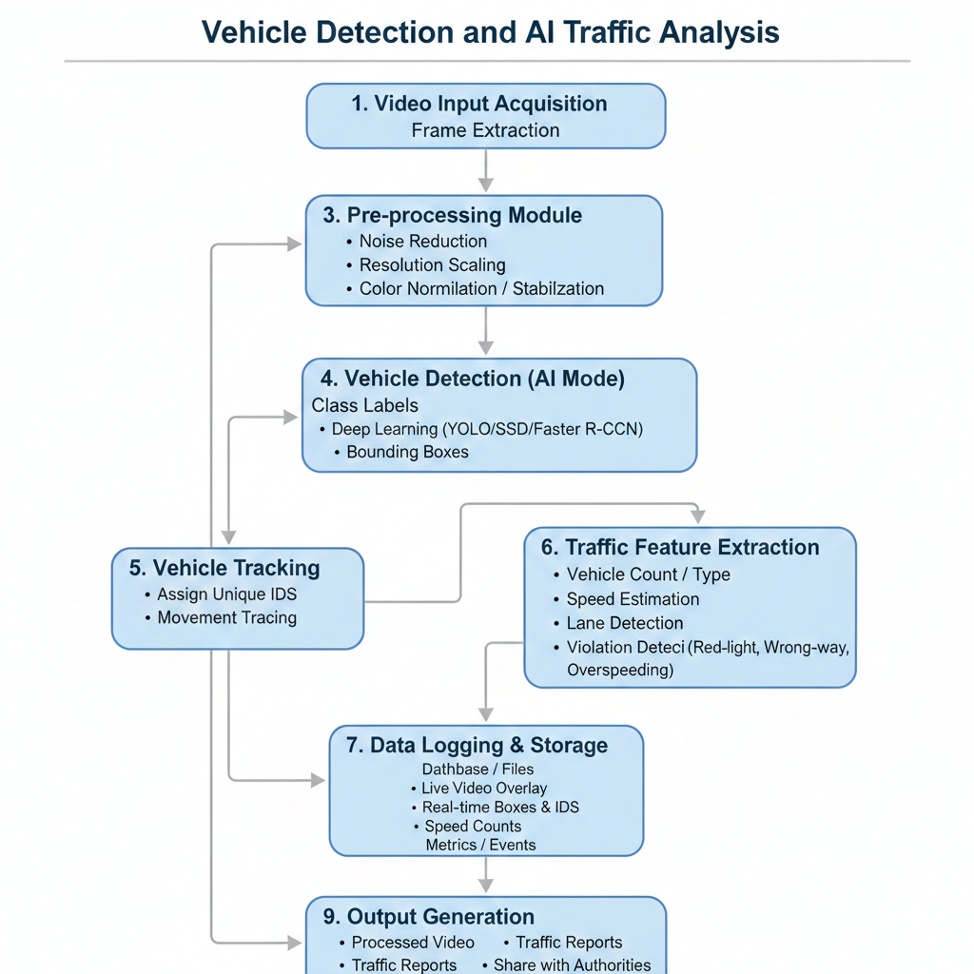

Table 3.1: Flow diagram of Vehicle Detection and

AI Traffic Analysis

DESCRIPTION OF THE WORK
The proposed system focuses on real-time vehicle detection, tracking, traffic analysis, and violation detection using artificial intelligence and computer vision techniques. The work integrates video data acquisition, deep learning-based object detection, vehicle tracking, traffic metric computation, and visualization to create a comprehensive traffic monitoring solution.
1. Video Data Acquisition
The system begins with capturing traffic data from multiple sources:
- CCTV cameras installed at intersections or highways
- Drone or aerial footage for monitoring larger areas
- Recorded videos for offline analysis
These videos serve as the primary input for the detection and analysis pipeline.
2. Pre-processing
Before analysis, the video frames are pre-processed to enhance detection accuracy:
- Frame extraction: Converts video into individual frames for analysis

- Noise reduction: Removes shadows, glare, and blur
- Resolution adjustment: Frames are resized to match the input requirements of AI models
3. Vehicle Detection
Vehicle detection is performed using state-of-the-art deep learning models such as YOLOv5, YOLOv8, Faster R-CNN, or SSD. Each frame is analyzed to:
- Identify vehicles in different categories (cars, trucks, buses, motorcycles, auto-rickshaws, etc.)
- Generate bounding boxes around each detected vehicle
4. Vehicle Tracking
Detected vehicles are tracked across consecutive frames using algorithms like DeepSORT or ByteTrack. This module:
- Assigns unique IDs to each vehicle
- Prevents double-counting during continuous monitoring
- Maintains movement trajectories for speed estimation and lane analysis
5. Traffic Feature Extraction
The system computes key traffic parameters:
- Vehicle count: Per frame, lane, or time interval
- Speed estimation: Based on displacement across frames and camera calibration
- Lane detection: Determines lane boundaries and vehicle positions
6. Data Logging and Storage
All detected information is logged into a database or files (CSV/Excel) for:
- Long-term traffic analysis
- Pattern recognition
- Enforcement reports
7. Visualization and Dashboard
A live dashboard displays:
- Processed video with bounding boxes, IDs, and speed labels
- Traffic flow charts, vehicle type distribution, and violation alerts
- Real-time updates for operators to monitor traffic efficiently
8. Output Generation
The system generates:
- Processed videos with overlays for review
- Reports in PDF or Excel format summarizing traffic statistics, vehicle counts, speed data, and violations

Chapter 4

RESULTS

- Uploading Input and Configuring Parameters:

This initial phase is critical as it establishes the data source and calibrates the detection engine before the computationally expensive processing begins. It transforms the application from a static script into a dynamic, user-controllable tool.
1. Data Ingestion (Video Upload Handling)
The system does not rely on hard-coded video paths. Instead, it utilizes a frontend interface to accept dynamic user inputs.
- Mechanism: The application employs the st.file_uploader widget from the Streamlit framework. This allows the user to browse their local directory and select video files in standard formats (MP4, AVI, MOV).
- Buffer Management: OpenCV, the library used for video processing, requires a physical file path to read frames. However, web uploads initially exist as byte streams in the system's RAM.
- Technical Solution: To bridge this gap, the system utilizes Python’s tempfile library. It intercepts the uploaded byte stream, writes it to a temporary file on the server's disk, and passes that temporary path to cv2.VideoCapture. This ensures seamless integration between the web frontend and the computer vision backend.
2. Dynamic Parameter Tuning
To ensure the system is adaptable to different environments (e.g., a foggy road vs. a clear highway), the sidebar allows for real-time parameter adjustment.
- Confidence Threshold (NMS Filter):
  - Input Type: Slider (Range: 0.1 to 1.0).
  - Function: This value controls the sensitivity of the YOLOv8 Neural Network. The model outputs a probability score (0-1) for every detected object.
  - Logic: If (Detection_Score < User_Threshold): Discard Object.
  - Impact: A higher threshold (e.g., 0.6) removes "noise" and false positives but might miss smaller vehicles. A lower threshold (e.g., 0.2) catches everything but may mistakenly identify a rock as a car.

- Speed Limit Configuration:
  - Input Type: Numerical Input.
  - Function: This sets the regulatory benchmark for the simulation logic.
  - Impact: This variable acts as the conditional trigger for the violation logic layer. If the simulated speed of a tracked object exceeds this input value ($V_{obj} > V_{limit}$), the system flags the vehicle as "Overspeeding."
3. State Initialization and Reset
Before processing begins, the system performs a "Sanitization" step to ensure data integrity.
- Session State Management: The application utilizes Streamlit’s session_state to manage variables that persist across reruns.
- Counter Reset: When a new video is loaded or the "Start" button is clicked, the specific set variable unique_ids = set() is cleared. This guarantees that the vehicle count starts at zero for every new session, preventing data pollution from previous analysis runs.

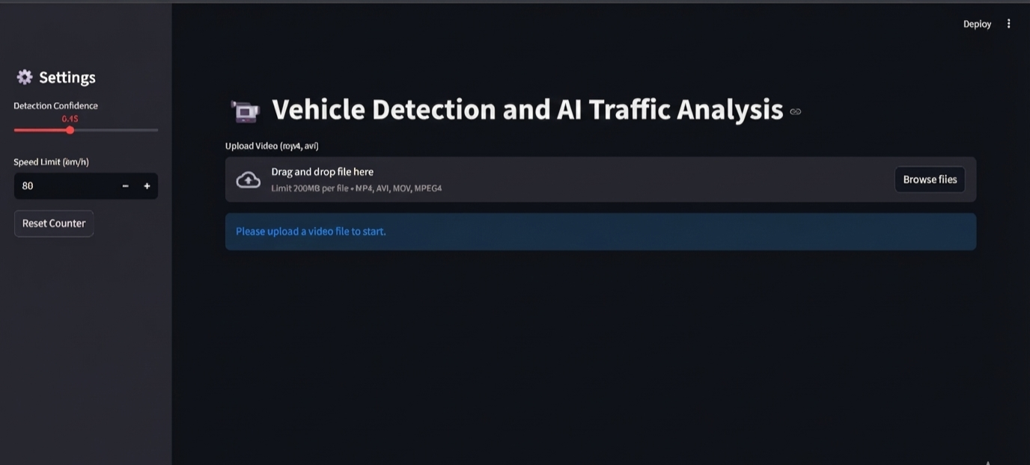

Fig 4.1: Uploading Input and Configuring Parameters

- Real-time Detection and Tracking:

This phase operates as a continuous loop, processing the video stream frame by frame. It is composed of two distinct but integrated deep learning technologies: YOLOv8 for detection and DeepSORT for tracking.
1. Object Detection with YOLOv8
The first step is to understand what is in a single, isolated frame. For this, we use the YOLOv8 (You Only Look Once, version 8) model.
- Function: YOLOv8 is a state-of-the-art Convolutional Neural Network (CNN). It analyzes an entire image in a single pass to simultaneously predict:
  - Classification: What the object is (e.g., Car, Truck, Bus, Motorcycle).
  - Localization: Where the object is, represented by a rectangular "bounding box" defined by coordinate points $(x_1, y_1, x_2, y_2)$.
  - Confidence Score: How certain the model is about its prediction (e.g., 92% sure it's a car).
- Process: The raw frame from the video is resized and fed into the YOLOv8 network. The network filters its output based on the user-defined Confidence Threshold and the specific target classes (IDs 2, 3, 5, 7 for vehicles), discarding irrelevant detections like people or traffic lights. The output is a list of validated bounding boxes for that specific frame.
2. Multi-Object Tracking (MOT) with DeepSORT
Detection alone is insufficient for traffic analysis because YOLO has no memory; it sees a "new" set of cars in every frame. To count vehicles accurately and calculate their speed, we must connect detections across time. This is handled by DeepSORT (Simple Online and Realtime Tracking with a Deep Association Metric).
- The Challenge (Occlusion & Motion): As vehicles move, their position changes. They may also be temporarily hidden (occluded) by larger vehicles or bridges. A simple distance-based tracker would fail in these scenarios, assigning a new ID to the same car when it reappears.
- DeepSORT's Solution: DeepSORT is a robust tracking algorithm that solves this using a two-pronged approach:

  - Motion Prediction (Kalman Filter): It uses a mathematical model to predict where an existing track should be in the current frame based on its past velocity.
- Data Association Process: In each new frame, DeepSORT compares the new detections from YOLO against its existing list of tracks. It matches them based on both their predicted location and their visual similarity.
  - Successful Match: The detection is added to an existing track, and its unique ID (e.g., "ID: 42") is maintained.
  - No Match: A new track is created with a new unique ID.
  - Track Loss: If a track is not matched for a certain number of frames (defined by max_age), it is considered to have left the scene and is deleted.
3. Visualization and Output Generation
The final step in this loop is to render the processed data back onto the video frame for the user.
- The system takes the stable track information from DeepSORT, which includes the bounding box coordinates, the assigned unique ID, and the vehicle type.
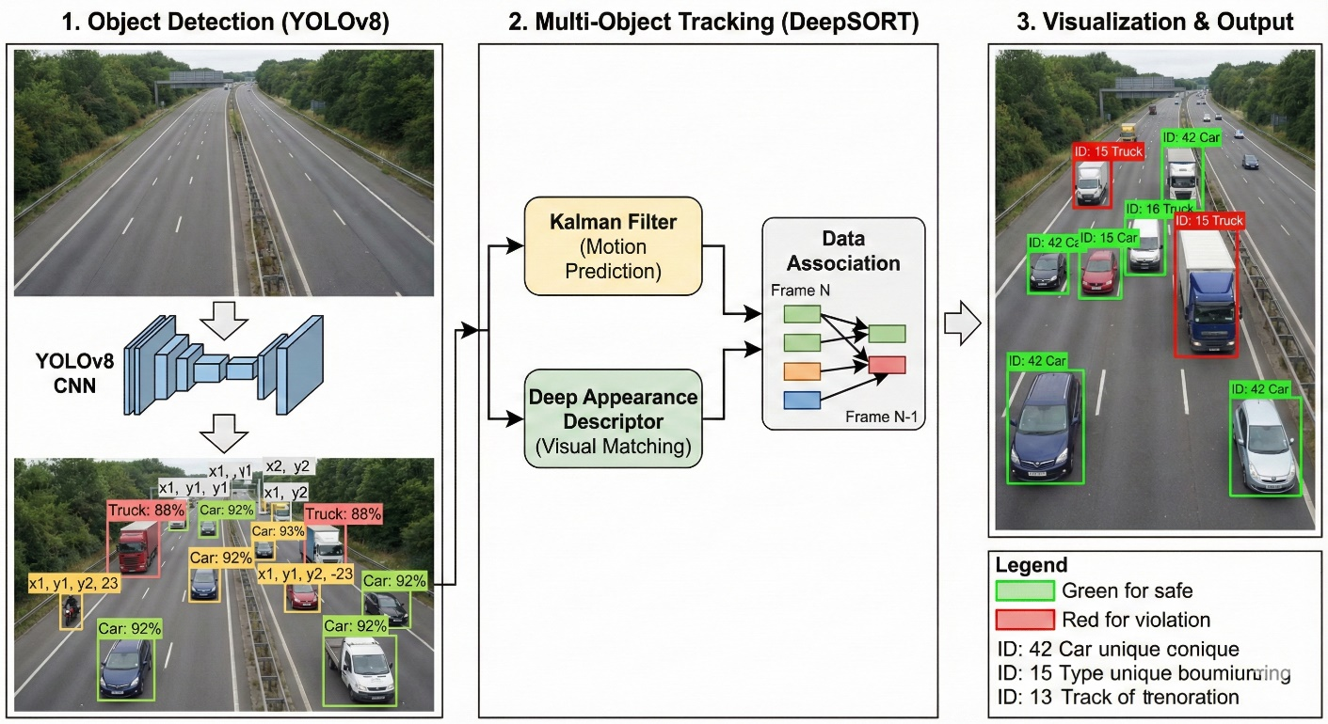
- Using OpenCV's drawing functions, a colored bounding box (Green for safe, Red for violation) is drawn around the vehicle.
.Fig 4.2:Real-time Detection and Tracking

- Violation Detection and Alert Generation

Once the DeepSORT algorithm has established a stable track for a vehicle, the system extracts its attributes—specifically its Vehicle Type and Spatial Position. These attributes are then passed through a rule-based logic engine to detect infractions.
1. Speed Limit Enforcement Logic
The system monitors the velocity of every tracked vehicle against the regulatory speed limit defined by the user in the sidebar.
- Speed Estimation:
In this demonstration environment, the system utilizes a Simulation Module. It assigns a realistic speed value to the vehicle based on its classification (e.g., assigning a lower speed range to Trucks/Buses and a higher range to Cars). In a fully calibrated real-world deployment, this would be replaced by pixel-displacement calculations mapped to real-world meters.
- Threshold Comparison:
The system executes a continuous conditional check for every frame:
$$If \ (V_{vehicle} > V_{limit}): \text{Status} = \text{VIOLATION}$$
- Result: This allows the system to instantly filter normal traffic from high-risk speeding offenders.
2. Lane Discipline Monitoring (Spatial Analysis)
Lane discipline is monitored by analyzing the geometry of the video frame and the position of the vehicle within it.
- Region of Interest (ROI) Definition:
The system mathematically divides the video frame width into zones. The far-right section of the frame (specifically, pixels $> 85\%$ of the frame width) is designated as the "Restricted Zone" (representing an emergency lane or hard shoulder).
- Centroid Calculation:
For every tracked vehicle, the system calculates the geometric center (centroid) of its bounding box:
$$Center_x = x_1 + \frac{(x_2 - x_1)}{2}$$
- Positional Check:
The logic checks if this $Center_x$ coordinate falls within the Restricted Zone. If it does, the vehicle is flagged for a Lane Violation.

3. Visual Alert Mechanism (Feedback Loop)
The final step is communicating these violations to the human operator through the dashboard interface. The system uses a visual hierarchy to distinguish between safe and unsafe vehicles immediately.
- Dynamic Bounding Box Coloring:
  - State A (Safe): By default, the rendering engine draws the bounding box in Green (RGB: 0, 255, 0).
  - State B (Violation): As soon as a boolean flag for is_overspeed or is_lane_violation becomes True, the rendering engine switches the color to Red (RGB: 255, 0, 0).
- Text Overlay Warnings:
To specify the nature of the violation, the system uses OpenCV to draw bold text alerts directly below the vehicle.
  - "OVERSPEED!": Indicates velocity infraction.
  - "LANE VIOLATION": Indicates spatial infraction.
This creates an immediate visual cue that allows an operator to assess the situation without reading the raw data metrics.

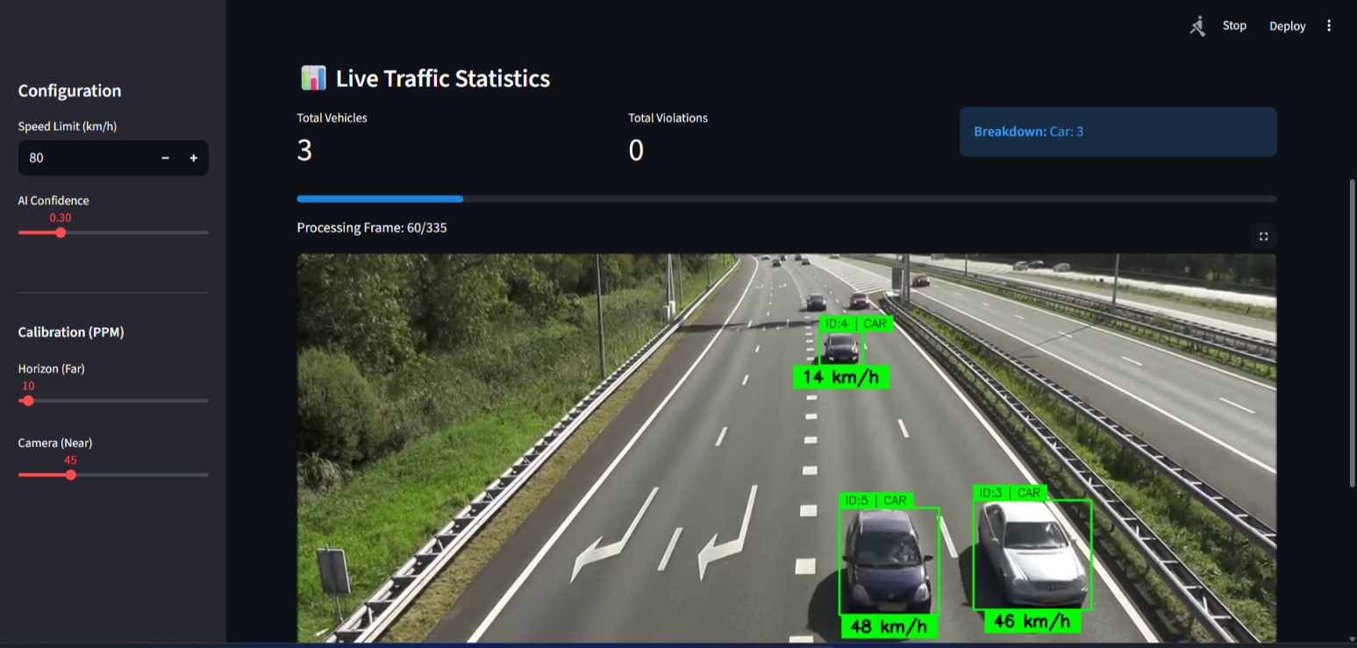
.Fig 4.3: Violation Detection and Alert Generation

- Final Analytics and Annotated Download:

While the video plays, the system is performing background operations to ensure that when the "Stop" button is clicked, the results are immediately available. This phase handles data persistence, video encoding, and file transmission.
1. Cumulative Data Aggregation (The Analytics)
Throughout the detection loop, the system maintains a live count of traffic volume.
- Session State Persistence: The system utilizes Streamlit's session_state to maintain a set of unique_ids. Unlike a simple integer counter that increments every frame, a Set data structure is used.
- De-duplication Logic:
$$Count_{total} = len(\{ID_1, ID_2, ..., ID_n\})$$
Because the set only allows unique values, if "Car ID 42" is detected in 100 consecutive frames, it is added to the set 100 times but counts as only one entry. This ensures the "Total Unique Vehicles" metric is statistically accurate and immune to frame-rate fluctuations.
2. Real-time Video Encoding (The Annotation)
The system does not wait until the end to draw the video. Instead, it acts as a real-time compositor.
- Frame Compilation: Inside the processing loop, after the bounding boxes (Green/Red) and text labels ("Overspeed") are drawn onto the pixel array, the frame is passed to the cv2.VideoWriter object.
- Codec Compression: The system uses the 'mp4v' (MPEG-4) codec to compress these frames into a coherent video file stored in the customized temporary directory.
- Synchronization: The writer ensures that the output video maintains the same Frame Rate (FPS) and Resolution as the source video, ensuring the playback speed of the downloaded file matches reality.
3. System Termination and Binary Delivery
When the user clicks "Stop," the system executes a safe shutdown procedure to prevent file corruption.
- Resource Release: The code executes cap.release() and out.release(). This "closes" the video file container, writing the final metadata headers required for video players to recognize the file duration.
- User Interface Delivery: A st.download_button is dynamically rendered. This button packages the byte stream with the MIME type video/mp4, allowing the browser to treat it as a standard file download labeled "traffic_analysis_output.mp4".

Chapter 5

CONCLUSION AND FUTURE ENHANCEMENTS

The developed AI-based vehicle detection and traffic analysis system successfully demonstrates how modern deep learning and computer vision technologies can be applied to real-time traffic monitoring. Through the integration of object detection models (such as YOLO), multi-object tracking algorithms (like DeepSORT), and analytical modules for speed estimation and violation detection, the system delivers a reliable and automated approach to monitoring traffic flow.
The experiments carried out under various environmental and traffic conditions show that the system performs with high accuracy in normal and moderately congested environments, providing consistent detection, stable tracking IDs, and correct classification of vehicles. The system also proves capable of identifying different types of violations such as overspeeding, lane indiscipline, and signal jumping. The visual dashboards and processed video outputs further enhance user understanding by providing clear and interpretable information for traffic authorities.
However, certain limitations were observed during testing in heavy rain, nighttime low-visibility conditions, and high-density traffic with extreme occlusions. These limitations highlight the complexity of real-world environments and the need for even more robust detection techniques. Despite these challenges, the system demonstrates strong potential to support intelligent traffic control, automated violation enforcement, and data-driven decision-making for urban traffic authorities.
Overall, the project achieves its core objectives—accurate vehicle detection, real-time tracking, traffic analysis, and violation reporting—thereby contributing a technologically advanced solution to modern traffic monitoring problems.

Future enhancements:
Despite the successful implementation, several improvements can be incorporated to make the system more advanced, scalable, and suitable for large-scale deployment:
1. Integration of Advanced Deep Learning Models
Future versions can use transformer-based vision models (e.g., DETR, RT-DETR) or hybrid CNN-transformer architectures for superior accuracy under low-light, foggy, or rainy conditions.

2. Incorporation of Multi-Camera Tracking
By linking multiple CCTV cameras, the system can track a vehicle across different junctions, allowing long-distance tracking, better traffic flow predictions, and improved incident detection.

3. Edge Deployment for Faster Processing
Running the model on edge devices like NVIDIA Jetson, Google Coral, or FPGA units can reduce latency and allow processing directly at the camera location, minimizing bandwidth requirements.

4. Predictive Traffic Modeling
A machine learning module can be added to predict traffic congestion, waiting times, and future flow patterns based on historical video data. This enables proactive traffic management.

5. License Plate Recognition (ANPR Integration)
Automatic Number Plate Recognition can be incorporated to identify vehicles involved in violations and to automate fine generation.

6. Weather-Adaptive and Night-Optimized Models
Training the model specifically on datasets captured in rain, fog, and nighttime can significantly improve detection stability in harsh environmental conditions.

7. Cloud-Based Data Storage and Dashboard
A cloud-connected platform can store long-term traffic data, allow remote monitoring by authorities, and provide advanced dashboards for analytics and reporting.

8. Incident and Accident Detection
Additional AI modules can detect abnormal events such as accidents, sudden stops, or wrong-direction driving, and automatically alert emergency services.

9. Integration With Smart City Infrastructure
The system can be integrated with adaptive traffic lights, IoT sensors, smart signboards, and traffic enforcement systems to create a fully intelligent transportation ecosystem.
.

REFERENCES
- Redmon, J., & Farhadi, A. (2018). YOLOv3: An Incremental Improvement. arXiv preprint arXiv:1804.02767.

- Bewley, A., Ge, Z., Ott, L., Ramos, F., & Upcroft, B. (2016). Simple Online and Realtime Tracking (SORT). IEEE International Conference on Image Processing (ICIP), 3464–3468.

- Wojke, N., Bewley, A., & Paulus, D. (2017). DeepSORT: Simple Online and Realtime Tracking with a Deep Association Metric. IEEE International Conference on Image Processing (ICIP), 3645–3649.

- Zhang, X., Zhao, X., & Kim, T. (2019). A Fast Vehicle Detection Algorithm for Intelligent Transportation Systems Using Deep Learning. Sensors, 19(12), 2771.

- Li, Y., Li, K., & Chen, Y. (2020). Vehicle Detection and Counting Based on Improved YOLO and SORT in Traffic Monitoring. IEEE Access, 8, 145389–145399.

- Geiger, A., Lenz, P., & Urtasun, R. (2012). Are We Ready for Autonomous Driving? The KITTI Vision Benchmark Suite. Conference on Computer Vision and Pattern Recognition (CVPR), 3354–3361.

- Gómez, P., Salgado, L., & López, M. (2018). Real-Time Vehicle Detection and Tracking in Highway Traffic Videos. Transportation Research Part C, 93, 170–189.

- Kamal, M., Imran, A., & Shafique, M. (2021). AI-Based Intelligent Traffic Surveillance System for Vehicle Detection and Violation Recognition. IEEE Transactions on Intelligent Transportation Systems, 22(6), 3621–3634.

- Hsieh, J., Chen, S., & Chen, D. (2006). Video-Based Traffic Analysis Using Motion Estimation. IEEE Transactions on Intelligent Transportation Systems, 7(3), 395–403.

- Liu, L., Ouyang, W., & Wang, X. (2016). SSD: Single Shot MultiBox Detector. European Conference on Computer Vision (ECCV), 21–37.

- Ren, S., He, K., Girshick, R., & Sun, J. (2015). Faster R-CNN: Towards Real-Time Object Detection with Region Proposal Networks. Advances in Neural Information Processing Systems (NeurIPS), 91–99.

